Exercise 1:

import requests

import html

# specify the url to find the bitcoin price

url = 'https://api.coindesk.com/v1/bpi/currentprice.json'

#get the live information from bitcoin url

response = requests.get(url)

# read the JSON data

response_json = response.json()

# obtain the GBP dictionary

gbp=response_json['bpi']['GBP']

# get the price

price=gbp['rate']

# get the html entity

symbol=gbp['symbol']

print(f"The Bitcoin price as a {type(price)} is {html.unescape(symbol)}{price}.")

Exercise 1:



The Bitcoin price as a <class 'str'> is £20,790.1829.

Exercise 2:

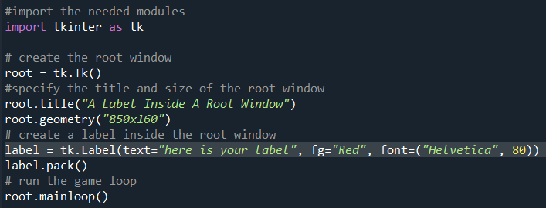

#import the needed modules

import tkinter as tk

# create the root window

root = tk.Tk()

#specify the title and size of the root window

root.title("A Label Inside A Root Window")

root.geometry("850x160")

# create a label inside the root window

label = tk.Label(text="here is your label", fg="Red", font=("Helvetica", 80))

label.pack()

# run the game loop

root.mainloop()

Exercise 2:

Exercise 3:

Exercise 3:

Exercise 4:

Exercise 4:

The latest value for DOW JONES is 33826.69!

The latest value for S&P500 is 4079.09!

The latest stock price for Microsoft is $258.06!

The latest stock price for Goldman Sachs is $368.5!

The latest stock price for Delta Airlines is $38.36!

Exercise 5:

Exercise 5:

The latest value for 13-Week Treasury Bill is 4.68!

The latest value for Five-Year Treasury Bond is 4.04!

The latest value for Ten-Year Treasury Bond is 3.83!

The latest value for 30-Year Treasury Bond is 3.89!